GUI Structured Testing Example

Initial GUI Launch Test Task

Set-up Steps
- Ensure that all “RBS PIS Slippage Model Install Instructions” in the ReadMe file were completed.
- Launch the GUI via Miniforge Prompt.
  - “cd plant-inspection-station-simulation”
  - “conda activate venv”
  - “streamlit run frontend.py”
- The graphical user interface (GUI) will load into your default browser

NOTE: You can access the test data files needed for the examples in this document inside the “data_input” folder in the main directory, which is found within the archive you moved into your username folder either via download or via git repository cloning.

- If this is your first time loading the GUI, confirm that the packages loaded into the GUI match the requirements.txt file.

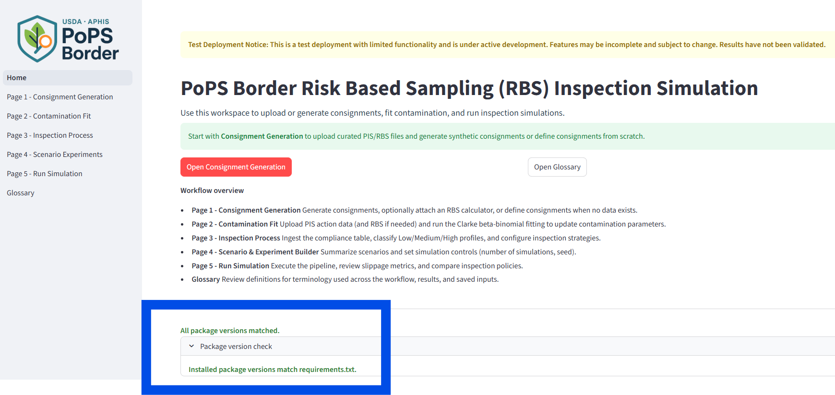

Task 1: Comparison of 2 RPS Policies
Context: You have been tasked with determining the “slippage”, defined as the quantity of plants that are not intercepted by inspection, which occurs as a result of two different “policies”, defined as methods of sampling. Policy 1 uses a method of sampling based on compliance levels for propagative materials/shipment’s country-of-origin. Policy 2 uses a method of sampling based on the producer names. Your task is to compare these policies to determine which policy is ‘better’, i.e., has less ‘slippage’.

- Begin the package
  - Click the “Open Consignment Generation” button on the “Home” page (in the left-hand page list).

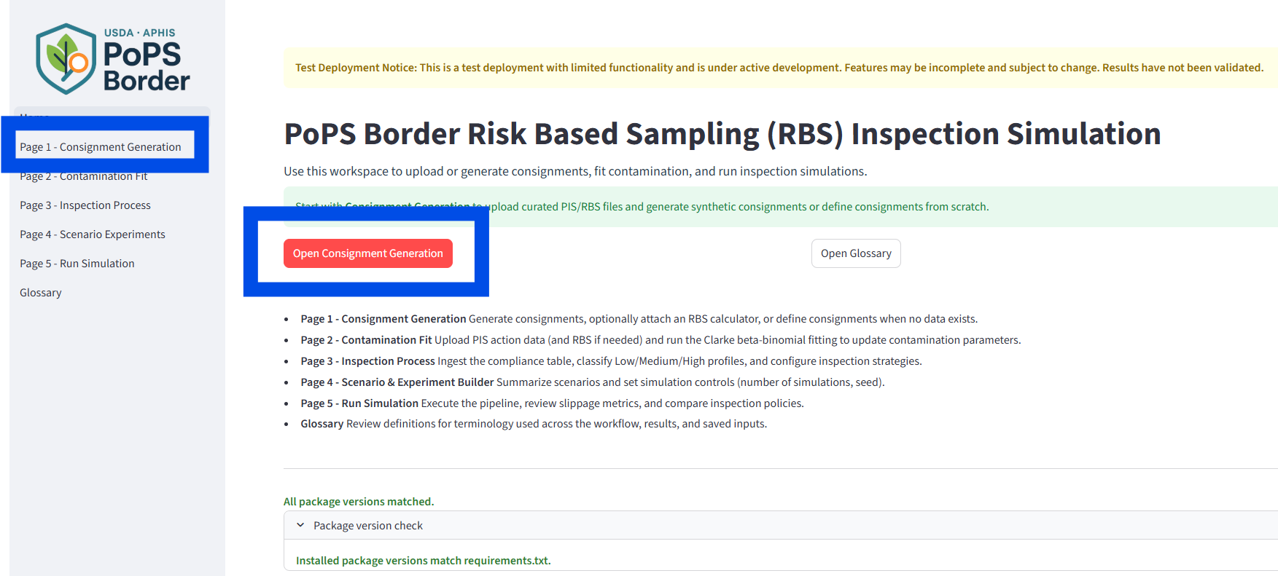

- Page 1 - Consignment Generation

Context: “We have data from our RBS calculators in ARM across ALL PIS’s and we want to use this to simulate consignments/shipments based on what has been seen in the past. We want to generate 100 hypothetical consignments/shipments using multinomial sequential sampling based on this test data to make our comparisons.”

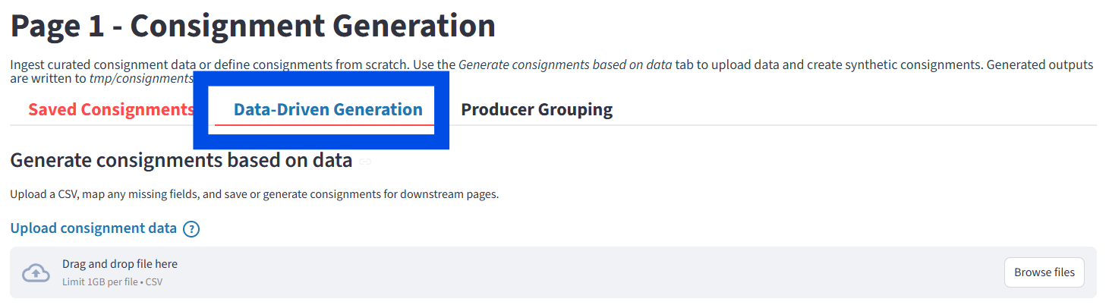
  - Select the second tab labeled ‘Data-Driven Generation’.
  - Click the “Browse files” button and upload the “CONSIGNMENT_DATA.csv” dataset into the application. You can find this file in the ‘data inputs’ subfolder within the plant-inspection-station-simulation folder you downloaded when installing the application.
  - Select “Generate synthetic consignments from data” as your ‘Consignment source for downstream analysis’.
  - Change the ‘Consignment input file base name’ to “Data Driven Consignments 1”.
  - Change the ‘Number of consignments to generate’ to “100”, select “multinomial sequential” as the ‘Sampling method’, and uncheck the box for using producer grouping.
  - Finalize and generate using the “Generate synthetic consignments” button.
  - When consignment generation is finished, you will see a green bar below it notifying you of the completed generation.
  - You can use this simulated consignment table as we proceed to the next section.
  - You can access generated files within the “tmp/consignments/” folder.
  - Select “Next Page” to proceed to the next exercise.

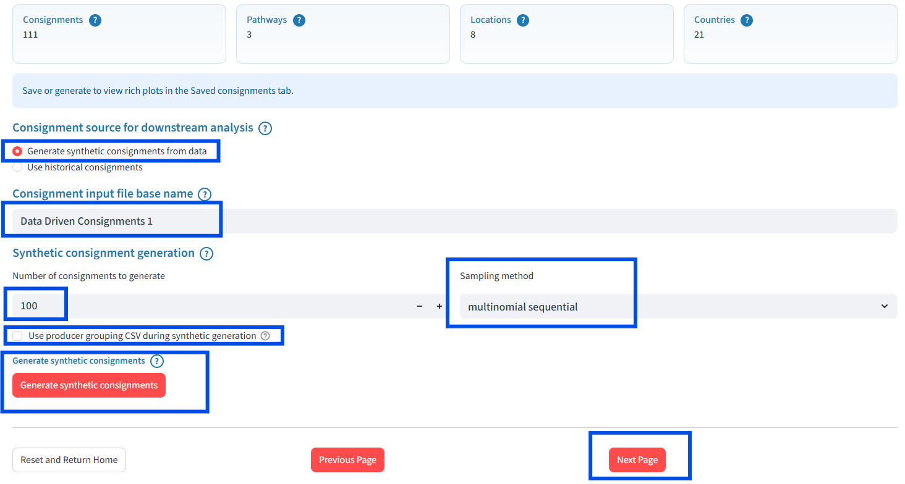
- Page 2 – Contamination Fit
Context: “We do not have contamination data so we will use expert-driven assumptions. Based on context from the past year, we estimate a contamination level of around 2% across inspection units. We are 75% confident in this average rate. Without data to fit contamination parameters, we must manually assign this rate as using parameters.”

  - Proceed to “Page 2 – Contamination Fit” then the “Assign contamination manually” tab.
  - Set the method of Contamination Assignment to “Specify Contamination Rate”.
  - Set the “Average Contamination Rate (0%-100%)” to “2.00”.
  - Move the “% Confidence” slider to 75.00.
  - Move the “clustering p” slider to 0.50

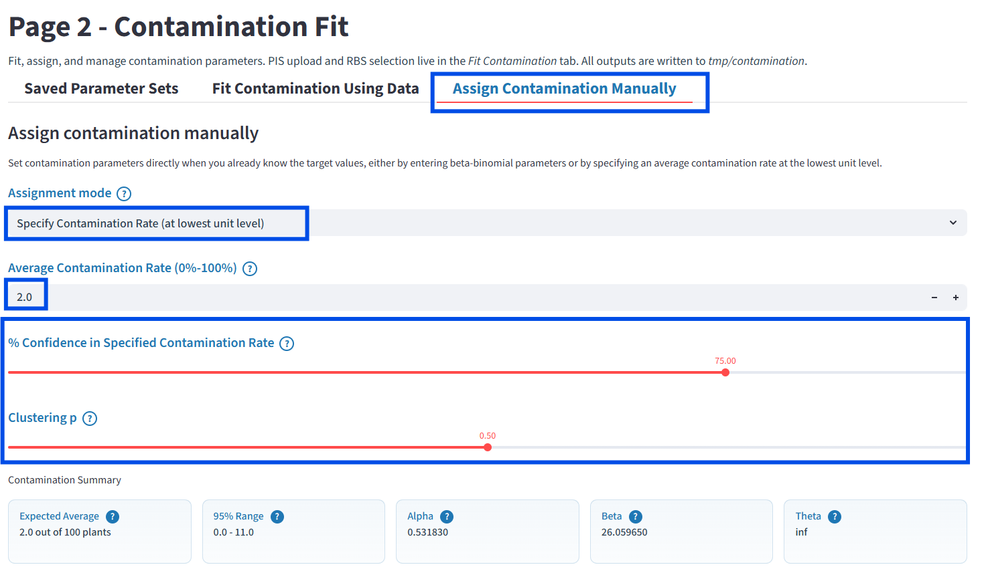

  - Change the parameter set name to “Fixed Contamination Rate 1”.
  - Save the current parameters.
  - Select “Next Page” to proceed to the next exercise.

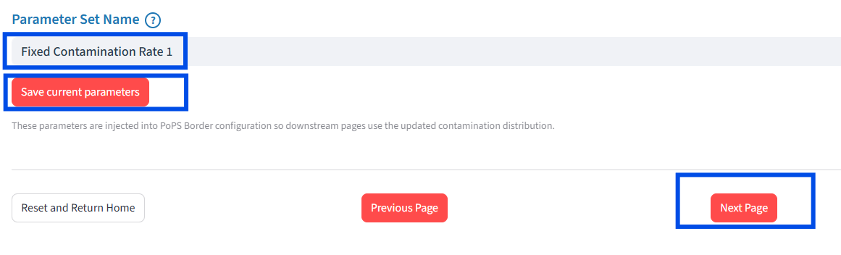
- Page 3 – Inspection Process
Context: “We have two set of compliance tables; The first one (OPM_COMPLIANCE_TABLE.csv) represents the policy currently in based on country-of-origin and propagative material type. Another team has developed a second table (OPM_PRODUCER_COMPLIANCE_TABLE.csv) which is based on only producer names. We want to compare the slippage between the two policies. Both policies use the same common file to map compliance to hypergeometric received from the RBS Policy Team (CONFIDENCE_DETECTION_LEVELS.csv).”

  - Proceed to “Page 3 – Inspection Process” and confirm the “Upload tables” tab is active.
  - Under “Compliance level upload”, upload the base compliance table called “OPM_COMPLIANCE_TABLE.csv”.
  - Under “Detection/confidence mapping upload”, upload the mapping table called
“CONFIDENCE_DETECTION_LEVELS.csv”.
  - Change the name to “Base Compliance”.
  - Save the compliance policy by clicking “Save Policy”. This will save the compliance policy as Base Compliance.pkl within the “tmp/compliance/” folder.

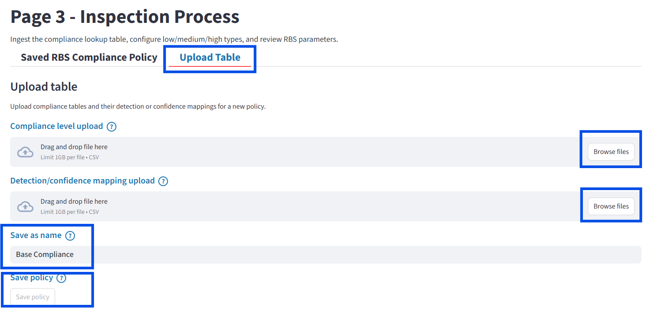

  - Scroll to the top of the page and change the “Compliance level upload” to the compliance table for producer names by uploading the second compliance table (called “OPM_PRODUCER_COMPLIANCE_TABLE.csv”).
  - Change the name to “Producer Name Compliance” and save the table.
  - You can select “Next page” to proceed to the next exercise.

- Page 4 – Scenario Experiments
Context: “Now that we have specified the input data and parameters for each aspect of the PIS simulation, we need to construct an experiment that tests and compares the current RBS strategy against the new RBS strategy.”

  - Proceed to “Page 4 – scenario Experiments” then the “Build experiments” tab.
  - Label the first scenario (row) “Scenario 1” in the “Scenario label” field.
  - Set the following parameters/input data for Scenario 1:
      - Consignment file = Data Driven Consignments 1
      - Contamination parameter set = Fixed Contamination Rate 1
      - Compliance table = Base Compliance.pkl
  - Add Scenario 1 to your experiment by clicking “Add scenario row.”

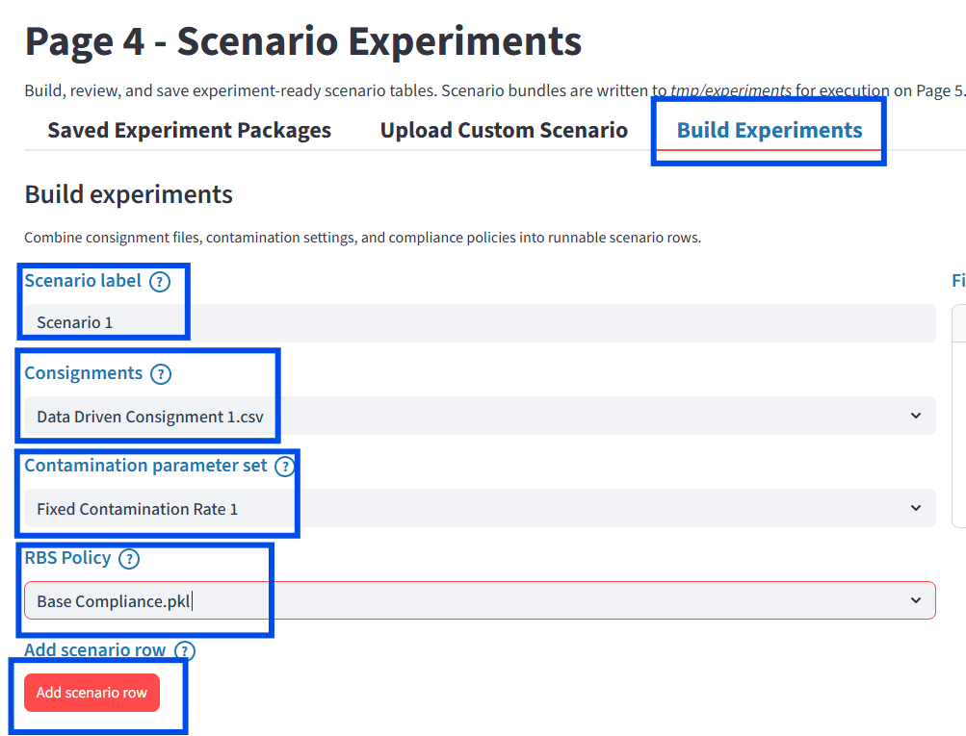
  - Build and label “Scenario 2” in the same manner using the following input data:
    - Consignment file = Data Driven Consignments 1
    - Contamination parameter set = Fixed Contamination Rate 1
    - Compliance table = OPM_PRODUCER_COMPLIANCE_TABLE.csv
  - Add Scenario 2 to your experiment by clicking “Add scenario row.”
  - Change your experiment set name to “Policy Practice Experiment”.
  - Save the experiment by selecting “Save experiment package”.
  - You can select “Next Page” to proceed to the next exercise.

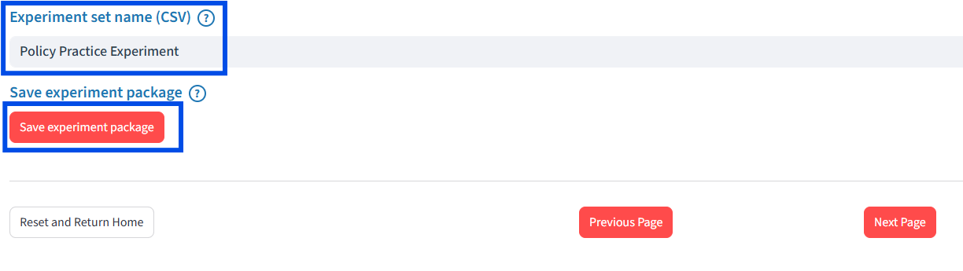

- Page 5 – Run Simulation
Context: “Everything is set up and we are ready to let the PoPS Border tool simulate our experiment.”

  - Proceed to “Page 5 – Run Simulation”.
  - Increase the number of simulation replications to three (3).
  - Make sure the correct experiment is displayed (“Policy Practice Experiment”) in the “Experiment to run” field.
  - Once everything is ready, click “Run Pipeline.” This will take some time as the PoPS Border tool runs in the background in the Miniforge Prompt window.

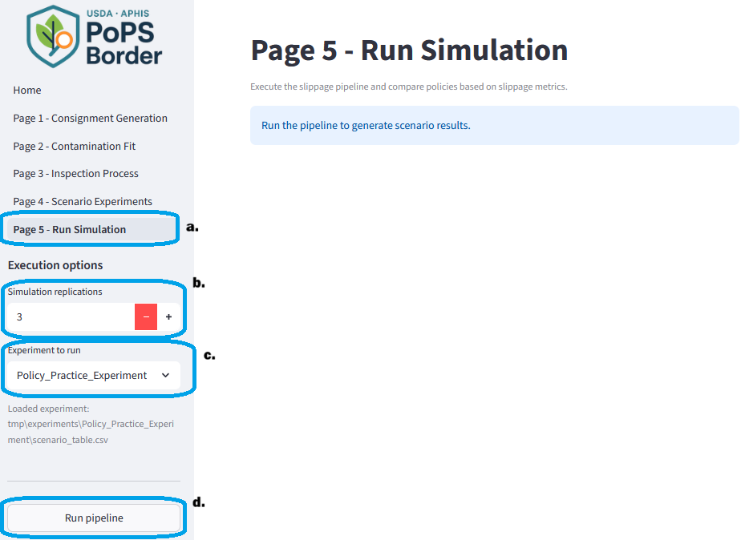

- What should be seen if you are running the correct version

The results will look similar to the screenshot below. You can now compare the two policies by looking at the output metrics for each scenario.

